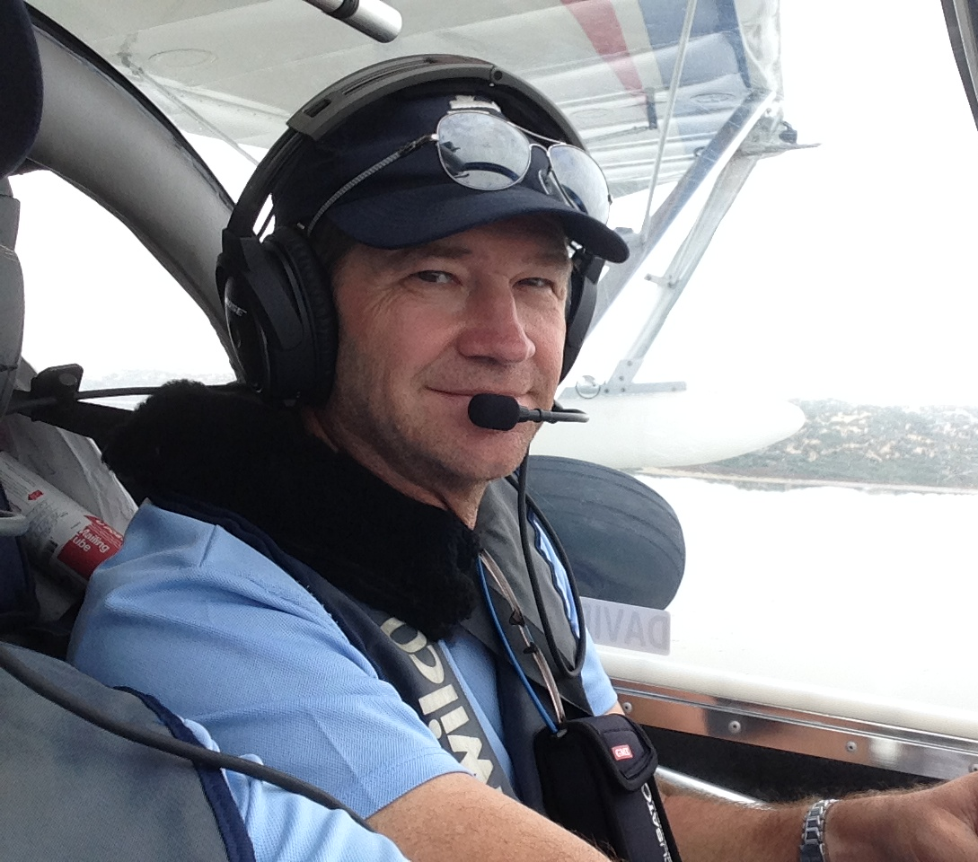
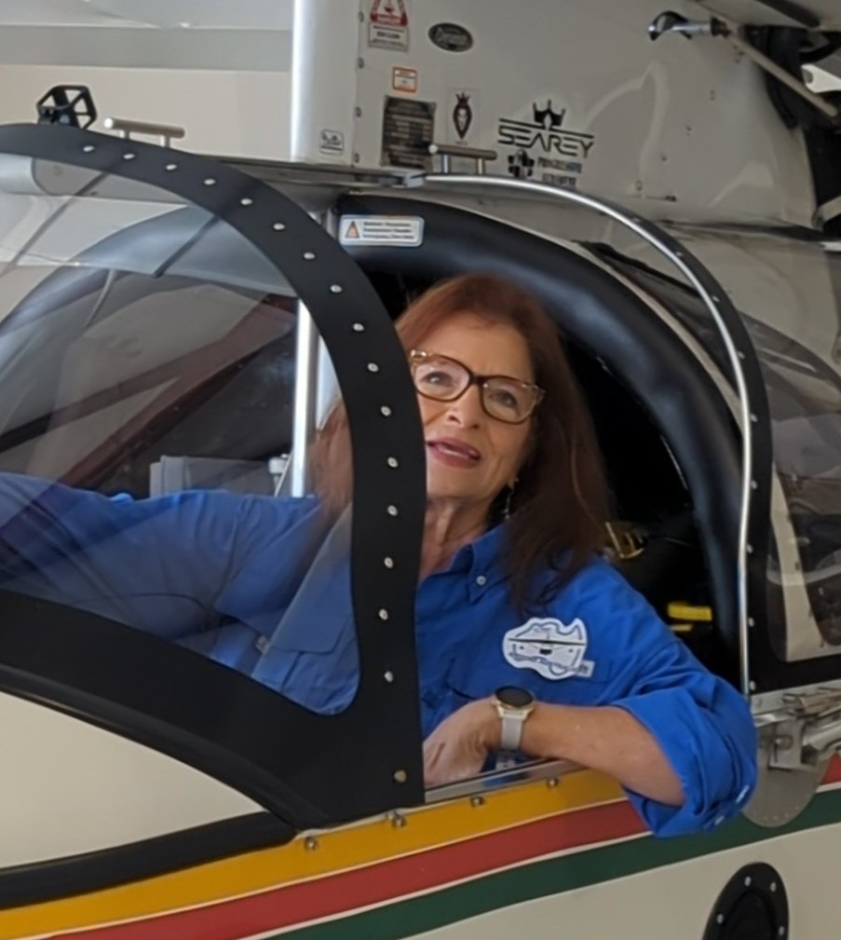

First Female Seaplane Pilot to Fly a Seaplane Around the Perimeter of Mainland Australia

Cathy Babis of St Louis, Missouri, USA and David Geers of Alderley, Queensland, Australia will share pilot duties in a SeaRey amphibian along with other aircraft, taking advantage of warmer temperatures and more favourable winds while also avoiding the end of the wet season up north. Throughout their adventure, they will promote STEM education and encourage diversity in all aviation occupations. Cathy will be making presentations at schools and clubs along the way. David hopes to do lots of joy flights, introducing young and sometimes disadvantaged children to the joys of water flying. They have also partnered with Roses in the Ocean to raise awareness of the lived experience of suicide.

About Cathy: She is a pilot with a passion for breaking barriers in aviation. She is new to seaplane flying, earning her commercial pilot seaplane certificate in September of 2020 with the Missouri River as her water runway near her home in St. Louis, MO, USA. With 53 years of aviation experience including, air traffic controller, former chief flight instructor for two flight schools, weather observer, aviation instrument map maker, historical reenactor of Amelia Earhart, & US Army veteran, she is dedicated to promoting aviation through STEM education and mentoring. On this historic flight, her goal is to emphasize the need for diversity in all aviation careers while inspiring women, from young girls just selecting a career to older women who may have put their flying dreams aside, to join the aviation community. Cathy says, “We believe that every barrier is meant to be broken. It's an honor to celebrate the circumnavigation’s 100th anniversary paying tribute to the pioneers who paved the way for us, while achieving a new “first” for female pilots." Promoting increased diversity, gender participation in aviation, and STEM education have been her mission for decades. She hopes her flight inspires and motivates people to consider embracing aviation as a vocation or avocation. Cathy is a member of a rare set of pilots – the .47% of all certificated US pilots who are female commercial seaplane pilots.
About David: He has been a pilot since 1980 and has flown his Searey amphibious airplane over 1000 hours since purchasing it in 2010. He is past president of the Seaplane Pilots Association of Australia and current committee member. He is passionate about flying, especially seaplanes.
Media Availability: Both pilots are available for in-person interviews in their local areas. In addition, they are available individually or together for virtual interviews. Please see the FAQ on our website for possible interview questions.
Contact:
Cathy Babis David Geers
cathybabis@gmail.com davidg@100asa.com.au
+1 314-443-7652 +61 418 10 35 35

